1： Convert from an adjacency matrix to adjacency lists

the time complexity is O(n^2) since you have two loops and itinerate all elements in N\*N array, and put them into Map, put operation takes O(1) so the total time is O(n^2)

2： Convert from an adjacency list to an incidence matrix.

The time complexity is O(n\*m), since we have to read all nodes and edges to reform the incidence matrix

3：Convert from an incidence matrix to adjacency lists.

The time complexity is O(n\*m), because you have to scan all elements in N\*M array and put them into map.

Test case graph

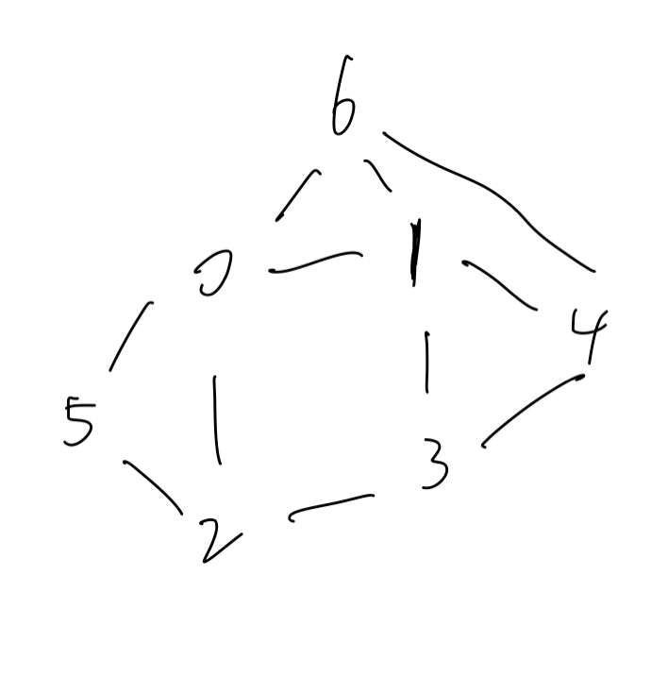

The result of Converting from an adjacency matrix to adjacency lists is :

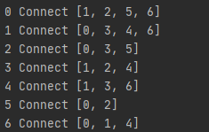

2. The result of Converting from an adjacency list to an incidence matrix is

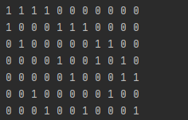

3.the result of Converting from an incidence matrix to adjacency lists is .

